**Exercise 2 : E-commerce Platform Search Function**

📌 **Understanding Asymptotic Notation and Big O Notation**

1️⃣ **Asymptotic Notation**

Asymptotic notation is used to describe how an algorithm’s running time or space requirement grows as the input size increases. It allows us to evaluate algorithm efficiency without worrying about hardware or coding details.

* **Big O Notation (O):**  
  Big O gives the *upper limit* of how long an algorithm might take to run, especially as the input becomes very large. It focuses on the worst-case growth to help us compare algorithms effectively.

2️⃣ **Types of Cases in Algorithm Analysis**

* **Best Case:** The quickest scenario — for example, finding the required item immediately.
* **Average Case:** The expected time taken, considering all possible inputs.
* **Worst Case:** The slowest scenario — like searching for something that isn’t there at all.

⚙️ Time Complexity Examples

* **Linear Search:**
  + Time Complexity → O(n) (Worst Case)
  + Reason → It might need to go through the entire list to find or confirm the absence of an item.
* **Binary Search:**
  + Time Complexity → O(log n) (Worst Case)
  + Reason → The search space is cut in half with each step, making it much quicker.

✅ **Choosing the Right Search**

* Linear Search is easy to use but gets slow when working with large lists.
* Binary Search is much faster but only works if the data is already sorted.
* For something like an e-commerce site with thousands of products, Binary Search would be ideal to make searches faster — as long as the product list stays sorted.
* **Implementation of E-Commerce Platform Search**

1. **Creation of Product Class :**

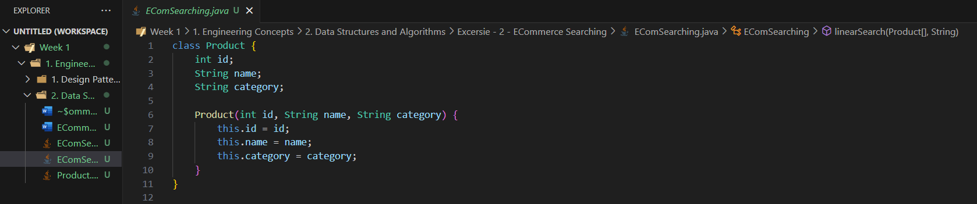

1. **Implementation of Searching Algorithms**
   1. **Linear Search :**

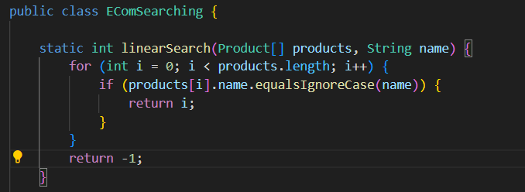

* 1. **Binary Search with Sorting array by name (Bubble Sort)**

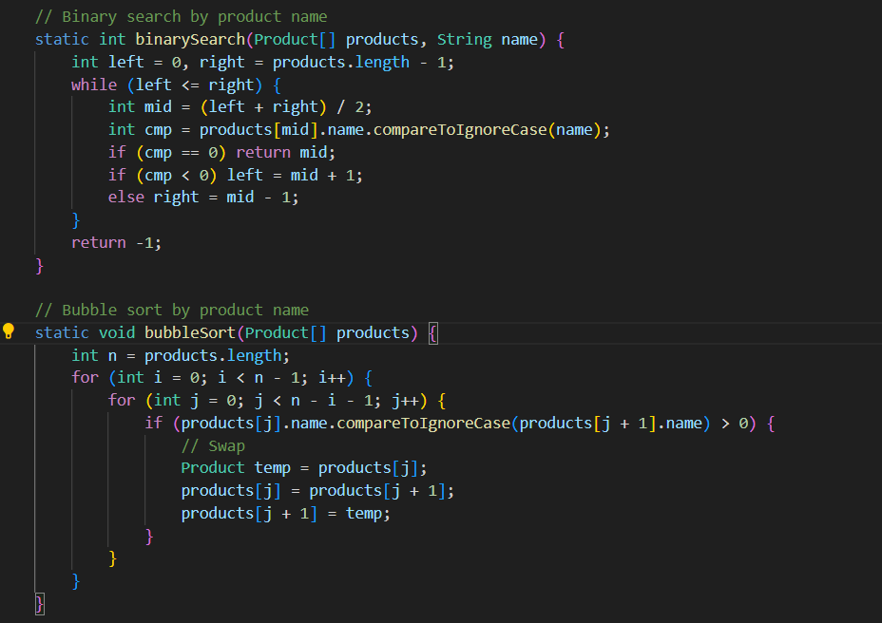

1. **Output**

